Bivariate Pearson, Spearman Correlations and Linear Regression
Student’s Name:
Instructor’s Name:
Institution:
Date:

Contents
Scatter plot 4
6.1 Interpretation and process 4
Scatter plot 5
Interpretation and process 5
Scatter plot 6
Interpretation and process 6
Descriptive statistics 7
Interpretation and process 7
Pearson correlation 8
Interpretation 8
Non parametric correlation 9
Interpretation 9
From the above output, we can conclude that student’s height in inches is same sex parent’s height with 0.845. 6.3 Interpretation and process 9
Descriptive statistics 10
Interpretation 10
Correlations 11
Interpretation 11
6.4 Interpretation and process 11
Variables Entered/Removed 12
Model summary 12
Interpretation 12
ANOVA 12
Interpretation 12
Coefficients 13
Interpretation 13
6.5 Interpretation and process 13
Descriptive statistics 14
Interpretation 14
Pearson’s correlation 15
Interpretation 15
Variables Entered/Removed 16
Model summary 16
Interpretation 16
ANOVA 17
Interpretation 17
Coefficients 17
Interpretation 18
6.6 a) Correlation Analysis 18
Scatter plot 18
Interpretation 19
Descriptive statistics 19
Interpretation 19
Pearson Correlations 19
Interpretation 20
Spearman’s correlation 20
Interpretation 20
b) Research question: How does gender affect the height of a student? 20
Descriptive statistics 21
Interpretation 21
Pearson Correlation 21
Interpretation 21
Model summary 22
Interpretation 22
ANOVA 22
Interpretation 22
Scatter plot 23
Interpretation 23
Coefficients 24
Interpretation 24
Reference 25

Scatter plot
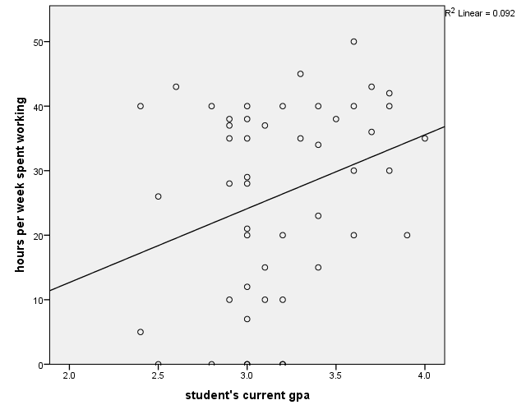

6.1 Interpretation and process
The data is linearly positive according to the figure above. Hence, in order to plot the scatterplot, the following process should be followed; open the SPSS software then import your data by clicking files option on the menu bar, then open data. Specify on the location of the data the after locating it click the data then open (Morgan et al., 2019). After opening the data on the menu bar click graphs then chart builder. Next choose scatter plot and drag to the dialogue box. on the dialogue box where you have dragged your scatter plot, drag students current gpa on the x-axis and hours per week spent working on the y-axis. Then click ok. Hence, from the output, student’s gpa is not affected by hours per week spent working since the results shows that they are positively linear (Morgan et. al. 2019).

Scatter plot
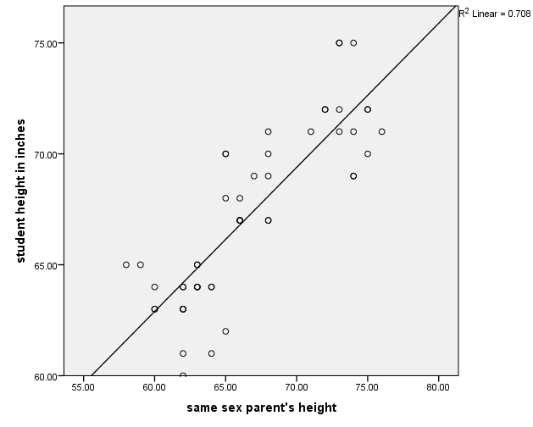

Interpretation and process
In order to plot the scatterplot, the following process should be followed; open the SPSS software then import your data by clicking files option on the menu bar, then open data. Specify on the location of the data the after locating it click the data then open. After opening the data on the menu bar click graphs then chart builder (Morgan et al., 2019). Next choose scatter plot and drag to the dialogue box. on the dialogue box where you have dragged your scatter plot, drag same sex parent’s height on the x-axis and student’s height in inches on the y-axis. Then click ok. Hence, from the output, the height of a student depends on the height of the same sex parent. For instance, a female student will be tall if the female parent is tall. Since the results shows that they are positively linear.

Scatter plot

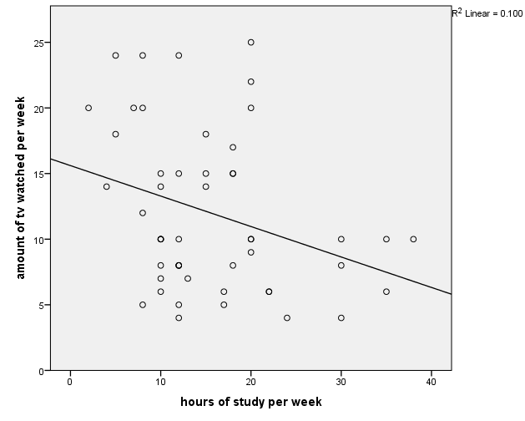

Interpretation and process
In order to plot the scatterplot, the following process should be followed; open the SPSS software then import your data by clicking files option on the menu bar, then open data. Specify on the location of the data the after locating it click the data then open. After opening the data on the menu bar click graphs then chart builder (Morgan et al., 2019). Next choose scatter plot and drag to the dialogue box. on the dialogue box where you have dragged your scatter plot, drag hours of study per week on the x-axis and amount of tv watched per week on the y-axis. Then click ok. Hence, from the output, the more hours a student studies per week, the less the amount of tv watched per week and vice versa since the data is negatively linear.

6.2

Descriptive statistics
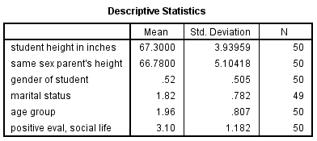

Interpretation and process
In order to carry out correlation analysis, the following process should be followed; open the SPSS software then import your data by clicking files option on the menu bar, then open data. Specify on the location of the data then after locating it click the data then open. On the menu bar, go to analyse option then click correlate. Next click bivariate. Choose your variables and drag them to the dialogue box. Next below the dialogue box tick the Pearson and spearman. On the right-hand side of the dialogue box, click options then select means and standard deviations then click ok (Morgan et al., 2019). From the descriptive statistics, the total number of the samples used in the output were 50 in all variables except for marital status which has one missing value. Moreover, the results showed that, student’s height in inches had the highest mean with 67.3. besides, same sex parent’s height data recorded the highest standard deviation which indicated that, the data was more spread.

Pearson correlation
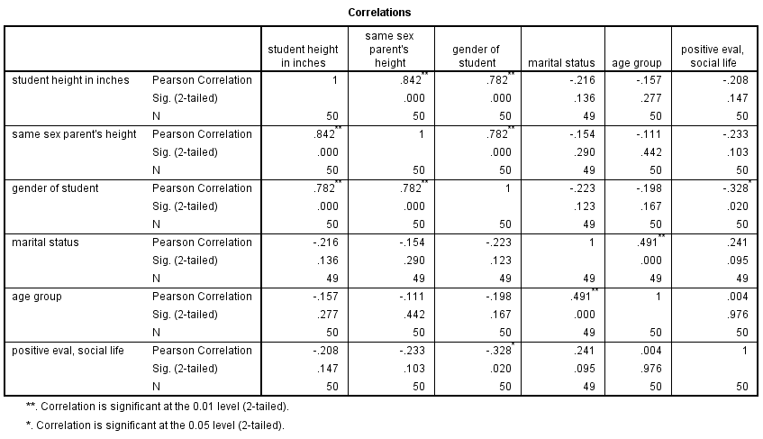

Interpretation
From the above output, we can conclude that student’s height in inches is same sex parent’s height with 0.842.

Non parametric correlation
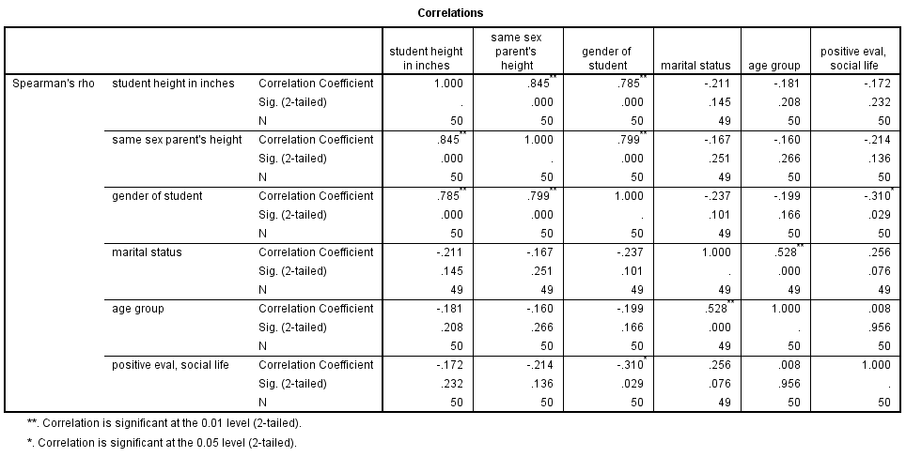

Interpretation

From the above output, we can conclude that student’s height in inches is same sex parent’s height with 0.845.
6.3 Interpretation and process
In order to carry out correlation analysis, the following process should be followed; open the SPSS software then import your data by clicking files option on the menu bar, then open data. Specify on the location of the data then after locating it click the data then open. On the menu bar, go to analyse option then click correlate (Morgan et al., 2019). Next click bivariate. Choose your variables and drag them to the dialogue box. Next below the dialogue box tick the Pearson. On the right-hand side of the dialogue box, click options then select means and standard deviations then click ok.

Descriptive statistics
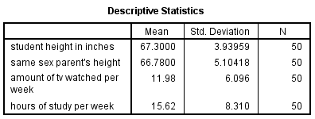

Interpretation
From the descriptive statistics, the total number of observations used in each case were 50. However, the student’s height in inches recorded the highest mean while amount of tv watched per week the minimum. Moreover, hours of study per week were more spread referring to the standard deviation.

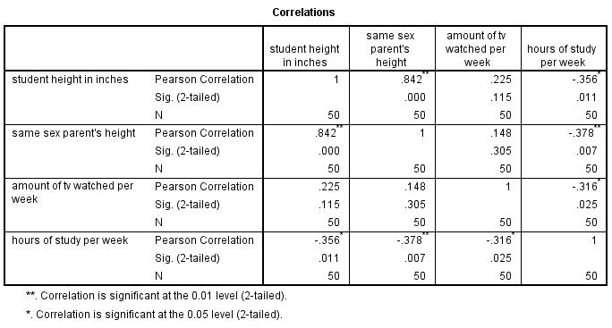
Correlations

Interpretation
From the output, the value of the diagonal matrix is 1. This implies that there was perfectly positive correlation between same variables. For instance, hours of study per week.

6.4 Interpretation and process
In order to carry out regression analysis, the following process should be followed; open the SPSS software then import your data by clicking files option on the menu bar, then open data. Specify on the location of the data then after locating it click the data then open. On the menu bar, go to analyse option then click regression (Morgan et al., 2019). Next click linear. Enter student’s current gpa as your dependent variable and hours of study per week as your independent variable.

Variables Entered/Removed
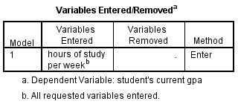

Model summary
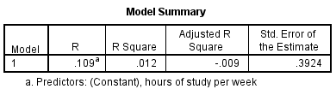

Interpretation
From the R square, 12% is explained by the model while 88% is explained by other factors which are not in the model.

ANOVA
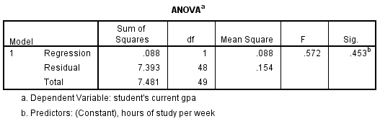

Interpretation
From the ANOVA output, the data was statistically insignificant since the p-value > 0.05. That is 0.453>0.05.

Coefficients
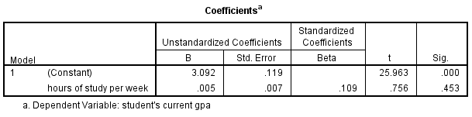

Interpretation
From the coefficients table, it is shown that, an increase in one unit of hours of study per week, will lead to an increase in students current gpa. This is shown by a positive constant (3.092).

6.5 Interpretation and process
In order to carry out regression analysis, the following process should be followed; open the SPSS software then import your data by clicking files option on the menu bar, then open data. Specify on the location of the data then after locating it click the data then open. On the menu bar, go to analyse option then click regression (Morgan et al., 2019). Next click linear. Enter student’s current gpa as your dependent variable and hours of study per week, hours per week spent working and amount of tv watched per week as your independent variables.

Descriptive statistics
Descriptive Statistics
 | Mean | Std. Deviation | N
student's current gpa | 3.176 | .3940 | 49
hours of study per week | 15.53 | 8.372 | 49
hours per week spent working | 26.12 | 14.857 | 49
amount of tv watched per week | 11.71 | 5.859 | 49

Interpretation
From the output, hours per week spent working recorded the highest average of 26.12 while student’s current gpa recorded the least with 3.176. The total sample used in each case was 49. In addition, hours per week spent working had the highest deviations which implied they were more dispersed as compared to the other.

Pearson’s correlation
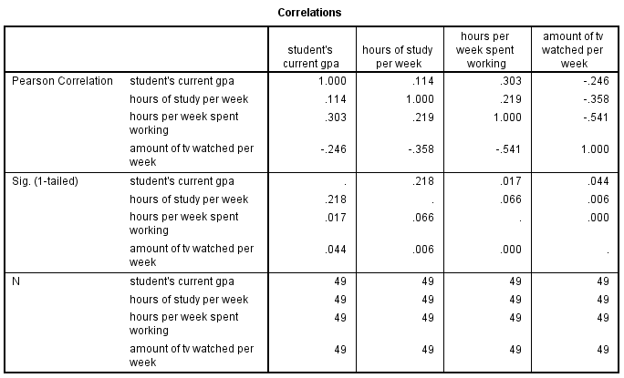

Interpretation
From the output, the value of the diagonal matrix is 1. This implies that there was perfectly positive correlation between same variables. For instance, hours of students current.

Variables Entered/Removed
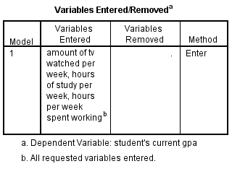

Model summary
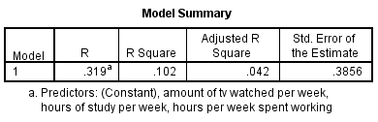

Interpretation
From the R square, 10.2 % is explained by the model while 89.8 % is explained by other factors which are not in the model.

ANOVA
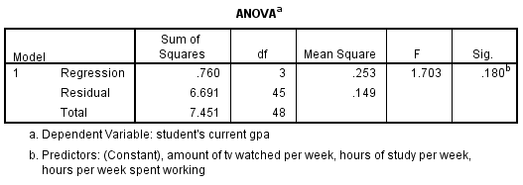

Interpretation
From the ANOVA output, the data was statistically insignificant since the p-value > 0.05. That is 0.18>0.05.

Coefficients
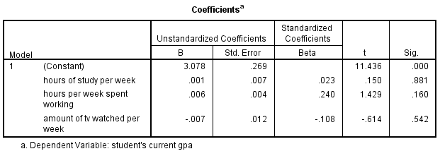

Interpretation
From the above output, an increase in one unit in hours of study per week and hours per week spent working lead to an increase in student’s current gpa while an increase in one unit of amount of tv watched per week will lead to a decrease in student’s current gpa.

6.6 a) Correlation Analysis
- Research Question
How will student’s height be affected by the height of the same sex parent?
- Null hypothesis: same sex parent’s height does not affect student’s height.

Scatter plot
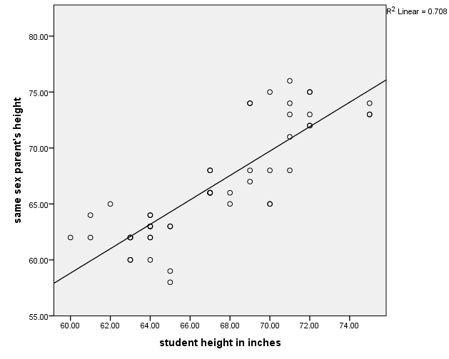

Interpretation
From the above output, there is a linear relationship. For instance, the data is positively linear. Also, there is neither an outlier nor a missing value. Hence the data is normal which indicates that it meets the assumptions of correlation.

Descriptive statistics

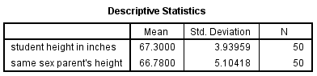
Interpretation
Total sample size was the same in all cases i.e. 50. Again, student’s height in inches recorded the highest average (67.3). From the standard deviations, same sex parent’s height data was highly dispersed.

Pearson Correlations
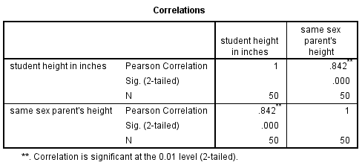

Interpretation
From the pearson correlation table, student’s height in inches was positively correlated to same sex parent’s height with a value of 0.842.

Spearman’s correlation
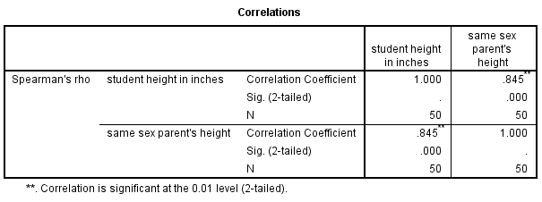

Interpretation
Also, from the spearman’s correlation table, student’s height in inches was positively correlated to same sex parent’s height.
- Research question: How does gender affect the height of a student?
Null hypothesis: gender does not affect the student’s height.
In order to carry out multiple regression for the data below, recoding “male” to (1= male and 0=not male) aided in easy handling of the data.

Descriptive statistics
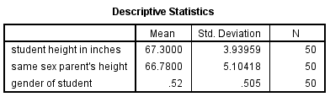

Interpretation
The total sample size used was 50. Student’s height in inches recorded the highest mean while gender recorded the lowest mean. Same sex parent’s height data was more spread out as compared to others.

Pearson Correlation
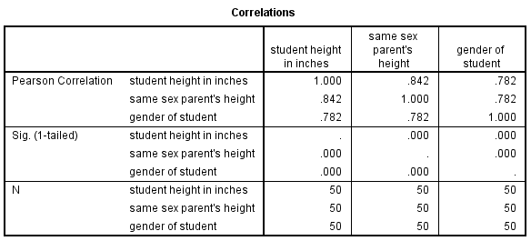

Interpretation
From the output, the value of the diagonal matrix is 1. This implies that there was perfectly positive correlation between same variables. For instance, student height in inches.

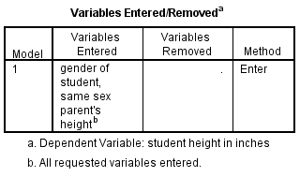

Model summary
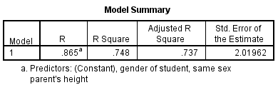

Interpretation
From the model summary output, 74.8% was explained in the model whereas 25.2% was explained by other factors that are not in the model.

ANOVA
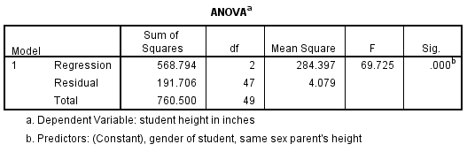

Interpretation
From the ANOVA table output, the p-value < 0.05 which implies that the data was statistically significant. i.e., 0.000<0.05.

Scatter plot

Interpretation
In this data there is linearity. To sum this, from the output, there is a positive linear relationship between student’s height in inches and same sex parent’s height. Again, the variables are not independent. for instance, if the student height is high, the same sex parent’s height is high.

Coefficients
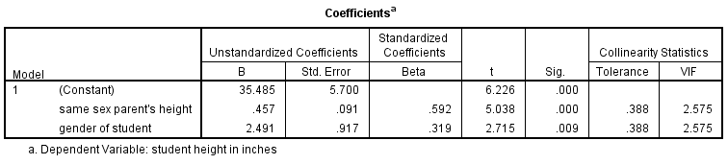

Interpretation
From the output, an increase in one unit of same sex parent’s height and gender of the student will lead to an increase in student’s height. Therefore, student’s height can be predicted.

Reference
Morgan, G. A., Barrett, K. C., Leech, N. L., & Gloeckner, G. W. (2019). IBM SPSS for Introductory Statistics: Use and Interpretation: Use and Interpretation. Routledge.

